**MEMBER**

**REPORT**

**[REPUBLIC OF KOREA]**

ESCAP/WMO Typhoon Committee

13th Integrated Workshop

Chiang Mai, Thailand

5-9 November 2018

**CONTENTS**

**I. Overview of tropical cyclones which have affected/impacted**

**Member’s area since the last Committee Session**

1. Meteorological Assessment
2. Hydrological Assessment
3. Socio-Economic Assessment

**II. Summary of Progress in Priorities supporting Key Result Areas**

1. The Web-based Portal to Provide the Products of Seasonal Typhoon Activity Outlook for the TC Members (POP1)
2. Technology Transfer of Typhoon Operation System (TOS) to the Department of Meteorology and Hydrology (DMH) of Lao PDR and the Thai Meteorological Department (TMD) of Thailand (POP4)
3. 2018 TRCG Research Fellowship Scheme by the Korea Meteorological Administration (KMA)
4. Co-hosting the 11th Korea-China Joint Workshop on Tropical Cyclones
5. Korea’s follow-on Geostationary Meteorological Satellite:GEO-KOMPSAT-2A
6. Preliminary Research on Establishment of Hydrological Data Quality Control in TC Members
7. Flood Damage Mitigation and Securing Water through Dam Control in Flooding
8. Improvement of Works to Expand Flood Forecasting Impacts
9. Enhancement of Flood Forecasting Reliability with Radar Rainfall Data
10. The Flood Risk Map and Information Service of the Waterfront Inundation
11. Setting up Early Warning and Alert System in Vietnam and Lao PDR 2018
12. Participation in Training Workshop for TC Community Weather Station Project (iCoWIN) 2018
13. The 13th Annual Meeting of Typhoon Committee Working Group on Disaster Risk Reduction
14. Participation in the PRiMO Conference
15. Sharing Information related to Disaster Risk Reduction
16. Making Education Video related to Disaster Risk Reduction
17. Expert Mission

**I. Overview of tropical cyclones which have affected/impacted Member’s area since the last Committee Session**

1. **Meteorological Assessment**

Twenty six typhoons have occurred up to 26 October 2018 in the western North Pacific basin. The number of typhoons in 2018 was higher than the 30-year (1981~2010) average number of occurrence (21.6) (Fig. I-1).

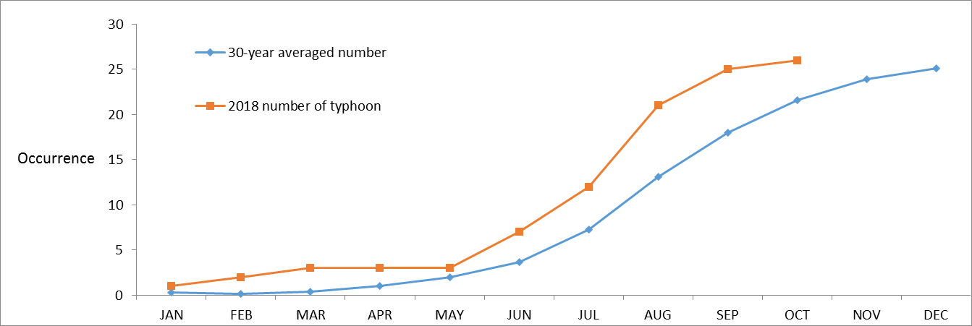

*Fig. I-1. The comparison of cumulative occurrence number of typhoon as of 26 October 2018*

It has been experienced the active typhoon season in the year. Five of Twenty six typhoons, PRAPIROON (1807), RUMBIA (1818), SOULIK (1819), TRAMI (1824) and KONG-REY (1825), influenced the peninsula during the period from July to October. SOULIK and KONG-REY made landfall in South Korea. PRAPIROON affected the southern part of the peninsula, and RUMBIA and TRAMI passed by off the southern coast of Jeju Island, entering into the area of warning responsibility of KMA. The tracks of the typhoons are presented in Fig. I-2.

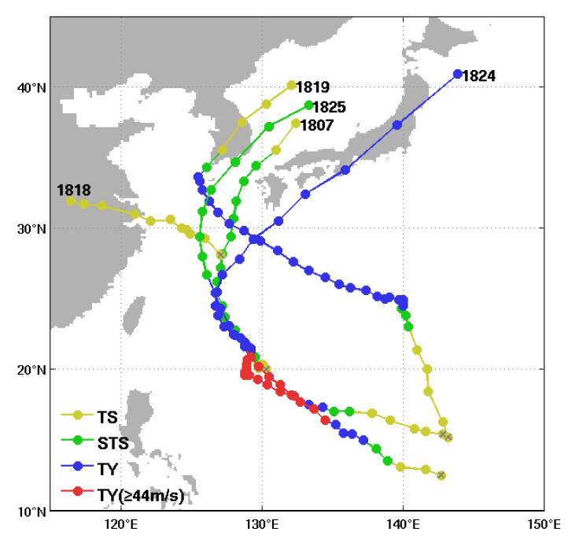

*Fig. I-2. TC tracks that affected the Korean Peninsula in 2018*

In particular, SOULIK, KONG-REY and PRAPIROON, impacted the Korean Peninsula with strong winds and heavy rain.

SOULIK was formed around 00UTC on 16 August over the ocean about 260km NW of Guam. In the early stage, it moved slowly and then went north-westward along the boundary of the Subtropical Ridge (STR) to the northeast. Then it lingered for almost 12hours near Jeju Island due to very complex environmental circumstance. After the time, it turned to north-east and landed in the South Jeolla Province, southeastern part of the peninsula around 14UTC 23 August. It stayed for another 12hours on the mainland until it went out to the East Sea. And then it was transformed into a extra-tropical cyclone around 18UTC 25 August over the East Sea about 480 km NE of Dokdo Island.

SOULIK passed slowly through the southwestern coast of Jeju from 22 to 23 August and Jeju experienced high winds and extremely heavy rainfall. During the period, 1113.0 mm was recorded at the Sajebi, a top of Mt. Halla in Jeju. The maximum wind speed of 30.2 m/s was observed at Gageodo in South Jeolla Province and the peak gust was 62m/s at Mt. Halla (Fig. I-3, Table. I-1).

|  |  |
| --- | --- |
| (a) Accumulated rainfall (22-23 August) | (b) The Maximum wind speed (23 August) |
| http://uis.comis4.kma.go.kr/tmp/aws/AWS_mrtN1_5_0_D_3_00_00_C_E30N_N_SP_560_201808240900_201808220901_0_3643671.png | http://uis.comis4.kma.go.kr/tmp/aws/AWS_dwMN1_5_0_D_3_00_00_C_E30N_N_SP_560_201808230000_201808220001_0_469695.png |

*Fig. I-3. Distribution of accumulated rainfall(left) and daily maximum wind speed(right)*

*during the passage of SOULIK (1819)*

Table. I-1. The extreme values measured at the weather stations

|  |  |  |  |
| --- | --- | --- | --- |
|  | Weather Station Location | Observation Value | Time |
| Minimum pressure | Jindo | 978.8 hPa | 12:01 UTC 23 August |
| Maximum wind speed | Gageodo | 30.2 m/s | 10:41 UTC 23 August |
| Peak Gust | Jindallae Bat(Mt. Halla) | 62.0 m/s | 19:25 UTC 22 August |
| Accumulated rainfall | Sajebi(Mt. Halla) | 1113.0 mm | 22-23 August |

KONG-REY was formed around 06UTC on 29 September over the ocean about 250km WSW of Guam. It moved north-westwards along the boundary of the STR to the north and turned to northeast direction off the coast of Jeju and landed in Gyeongsang Province, southeastern part of the Korean Peninsula around 01UTC 6 October. And then it was transformed into a extra-tropical cyclone around 00UTC 7 October over the sea near the Sapporo in Japan.

KONG-REY impacted on Jeju Island and southern regions of the Korean Peninsula. During the passage from 4 to 5 October, the accumulated precipitation of 714.0 mm was recorded on Mt. Halla. The maximum wind speed of 31.5 m/s was observed at Maemuldo in Gyeongsang Province and the peak gust of 53.0m/s was on Mt. Halla (Fig. I-4, Table. I-2).

|  |  |
| --- | --- |
| (a) Accumulated rainfall (4-5 October) | (b) The Maximum wind speed (5 October) |
| http://uis.comis4.kma.go.kr/tmp/aws/AWS_mrtN1_5_0_D_3_00_00_C_E30N_N_SP_560_201810060900_201810040900_0_7190638.png | http://uis.comis4.kma.go.kr/tmp/aws/AWS_dwMN1_5_0_D_3_00_00_C_E30N_N_SP_560_201810050000_201808220901_0_321695.png |

*Fig. I-4. Distribution of accumulated rainfall(left) and daily maximum wind speed(right)*

*during the passage of KONG-REY (1825)*

Table. I-2. The extreme values measured at the weather stations

|  |  |  |  |
| --- | --- | --- | --- |
|  | Weather Station Location | Observation Value | Time |
| Minimum pressure | Namhae(western part) | 977 hPa | 23:47 UTC 5 October |
| Maximum wind speed | Maemuldo | 31.5 m/s | 21:17 UTC 5 October |
| Peak Gust | Sajebi(Mt. Halla) | 53.0 m/s | 14:10 UTC 5 October |
| Accumulated rainfall | Witse Oreum(Mt. Halla) | 714.0 mm | 4-5 October |

PRAPIROON was formed around 00UTC on 29 June over the ocean about 740km SSE of Okinawa. It moved northwards along the boundary of the STR to the east passing over the Korea Strait onto the East Sea. In Gyeongsang Province, the accumulated precipitation of 201.0 mm was recorded on 3 July and the maximum wind speed of 24.7 m/s and the peak gust of 31.4m/s were observed (Fig. I-5, Table. I-3).

|  |  |
| --- | --- |
| (a) Accumulated rainfall (3 July) | (b) The Maximum wind speed (3 July) |
| http://uis.comis4.kma.go.kr/tmp/aws/AWS_mrtN1_5_0_D_3_00_00_C_E30N_N_SP_560_201807040900_201807030900_0_754642.png | http://uis.comis4.kma.go.kr/tmp/aws/AWS_dwMN1_5_0_D_3_00_00_C_E30N_N_SP_560_201807030000_201807030000_0_251687.png |

*Fig. I-5. Distribution of accumulated rainfall (left) and daily maximum wind speed (right)*

*during the passage of PRAPIROON (1807)*

Table. I-3. The extreme values measured at the weather stations

|  |  |  |  |
| --- | --- | --- | --- |
|  | Weather Station Location | Observation Value | Time |
| Minimum pressure | Geoje | 984.3 hPa | 10:06 UTC 3 July |
| Maximum wind speed | Ganyeoam(Yeosu) | 24.7 m/s | 03:30 UTC 3 July |
| Peak Gust | Ganyeoam(Yeosu) | 31.4 m/s | 04:00 UTC 3 July |
| Accumulated rainfall | Maegok (Ulsan) | 201.0 mm | 3 July |

1. **Hydrological Assessment**

Among twenty five typhoons that have taken place in 2018, the typhoons that directly or indirectly affected South Korea until last September were typhoon PRAPIROON (1807), RUMBIA (1818), SOULIK (1819), TRAMI (1824), and KONG-REY (1825). Of these, the typhoon SOULIK and Typhoon KONG-REY landed on the Korean Peninsula.

The first Korea-impacting typhoon PRAPIROON occurred at 00UTC on 29 June at the south-south-east sea of Okinawa, Japan and rainfall exceeded 200 mm until the typhoon dissipated in the northeast sea of Dokdo at 10UTC on 19 July.

The RUMBIA occurred at 06UTC on 15 August in the north-north-west sea of Okinawa, Japan. It landed on the south-south-west of Shanghai, China at 06UTC on 18 August and dissipated after causing enormous damage to China. The cloud formed on the front caused rain to fall frequently bringing relief to southern region of South Korea from heat wave.

The SOULIK occurred in the northwest of Guam at 00UTC on 16 August. It landed near Mokpo City in South Jeolla Province, South Korea at 14UTC on 23 August and passed through inland areas including Gwangju, Daejeon, Chungju and Pyeongchang. Then the SOULIK went out to the East Sea at 02UTC on 24 August and dissipated at 18UTC on 25 August at the north-north-east of Dokdo Island, South Korea. Initially, it was forecasted that the SOULIK would cause as much damage to South Korea as the Typhoon KOMPASU in 2010, and the entire nation, including schools, was put into an emergency. However, as landing, the intensity became much lower than forecasted. In the period that the RUMBIA, SOULIK, and followed rainfall, Korea, which have been suffering from drought, could secure water resources to supply until the flood season of next year.

The Flood Control Offices of South Korea issued 19 flood watches and 4 flood warnings nationwide in 2018. The level of the flood crisis warning was divided into four stages, and the dissemination of the flood risk was transferred to the public through mobile phone text transmission. Also the dissemination by text message of flood information was carried out for the related organizations to manage facilities around rivers.

1. **Socio-Economic Assessment**

From January to October 2018, five typhoons affected the Republic of Korea (Table I-4). Two of them, one is SOULIK(1819), and the other one is KONG-REY(1825), caused casualties and economic damages the most.

Table I-4. List of typhoons which have affected the Republic of Korea in 2018

|  |  |  |
| --- | --- | --- |
| **No.** | **Typhoon Name** | **Duration** |
| 1807 | PRAPIRROON | 2018.06.29.~2018.07.04 |
| 1818 | ROMBIA | 2018.08.15.~2018.08.18 |
| 1819 | SOULIK | 2018.08.16.~2018.08.25. |
| 1824 | TRAMI | 2018.09.21.~2018.10.01. |
| 1825 | KONG-REY | 2018.09.29.~2018.10.07 |

(By the courtesy of KMA web site, www.weather.go.kr)

From 22 to 25 August 2018, typhoon SOULIK (1819) made landfall over the southwestern part of the Korean Peninsula, and then passed through Gangneung Province. The Ministry of the Interior and Safety (MOIS) announced officially to operate the Central Disaster and Safety Countermeasure Headquarters at 18 KST on August 21. During its passage, it was observed that precipitation in Jeju was over 1,000 mm. The MOIS reported that one woman was missing around the coast of Jeju, and three people were injured.

And 362 facilities (338 public sector and 24 private sector) were damaged. Typhoon SOULIK caused power outage at 26,830 houses and flooding in farm land more than 3,063 ha. The team of damage investigation has assessed the damage on September, and they reported that the amount of the damage was over 8 million USD (4.8 million USD in public sector and 3.2 million USD in private sector).

(The above information is based on the MOIS report, the Safety Management Daily Monitoring on August 25.)

Table I-5. Regional damage and expected recovery cost by Typhoon SOULIK

|  |  |  |  |
| --- | --- | --- | --- |
| **Name of province** | **Number of the damaged local province** | **Damage costs (USD)** | **Recovery costs (USD)** |
| **Total** | **34** | **8,072,426** | **33,328,970** |
| **Gangwon** | 3 | 517,452 | 431,065 |
| **Jeonbuk** | 6 | 62,827 | 321,990 |
| **Jeonnam** | 19 | 5,791,449 | 26,961,606 |
| **Gyeongbuk** | 2 | 7,853 | 4,363 |
| **Gyengnam** | 3 | 3,490 | 17,452 |
| **Jeju** | 1 | 1,689,354 | 5,592,496 |

(By the courtesy of MOIS Official Report on August 18, Recovery Plan for Typhoon SOULIK and Storm)

From 4 to 10 October 2018, typhoon KONG-REY made landfall over the southern part of the Korean Peninsula including Jeju with strong wind and heavy rainstorm. MOIS announced the Central Disaster and Safety Countermeasure Headquarters at 9 KST on 5 October, and started typhoon monitoring with related ministries.

They reported that two people were killed and one man was missing while crossing a flooded bridge. During the event of the typhoon, it rained heavily in Jeju, Namhae and Yeongdeok. MOIS issued a flood warning in four regions of Nakdong-river and two regions of Hyeongsan-river. As of 8 October, 2,049 facilities (311 public sector and 1,738 private sector) were damaged. 1,407 houses and farm land over 660 ha were flooded by typhoon KONG-REY. 73 percent of facilities damages were recovered until October 8. Moreover, MOIS is planning to implement a recovery and inspection of the facilities in vulnerable area in order to estimate typhoon damage.

All the data of typhoon damage in 2018 will be published on Statistical Yearbook of Natural Disaster next year.

(The above information is based on the MOIS report, the Safety Management Daily Monitoring on October 8.)

**II. Summary of Progress in Priorities supporting Key Result Areas**

1. **The Web-based Portal to Provide the products of Seasonal Typhoon Activity Outlook for TC Members (POP1)**

The KMA has issued the seasonal outlook for typhoons occurring in the western North Pacific basin on its website (<http://gtaps.kma.go.kr/TSP/index.php>) since 2014. The information about the number of typhoons and track pattern is provided based on the results of three types of models: Multi-regression model, Global dynamical model, and Hybrid model of statistical and dynamical method. Further information is also available including climate monitoring, model verification, and model information (Fig. II-1).

In 2018, the KMA provided TC Members with the seasonal outlook for western North Pacific typhoonactivity on the website. The seasonal outlooks for summer and fall were issued in late May and late August, respectively. In the fall (Sep.-Nov.) seasonal outlook, nine to twelve typhoons were forecasted to occur. Storm frequency would be above normal in the eastern sea of Taiwan and southern Sea of Japan, and below normal in the South China Sea.

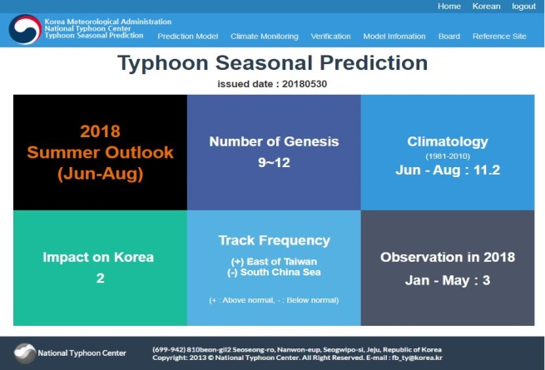 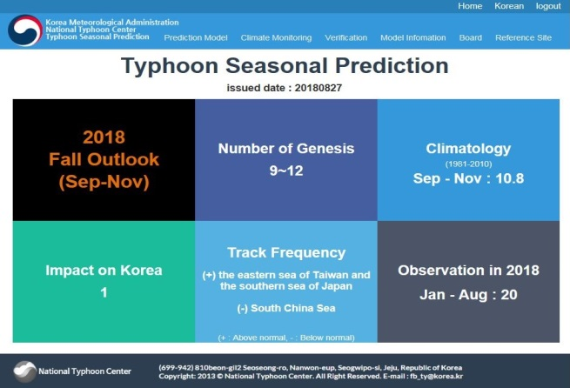

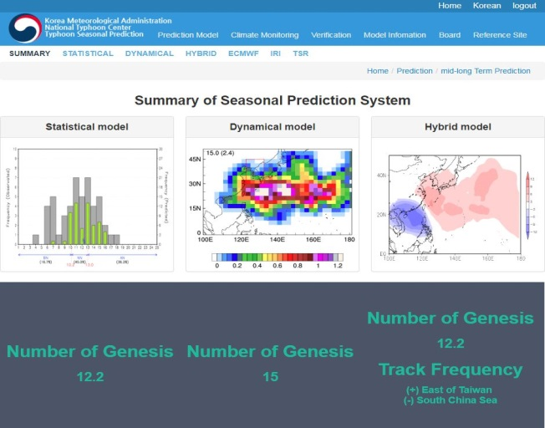 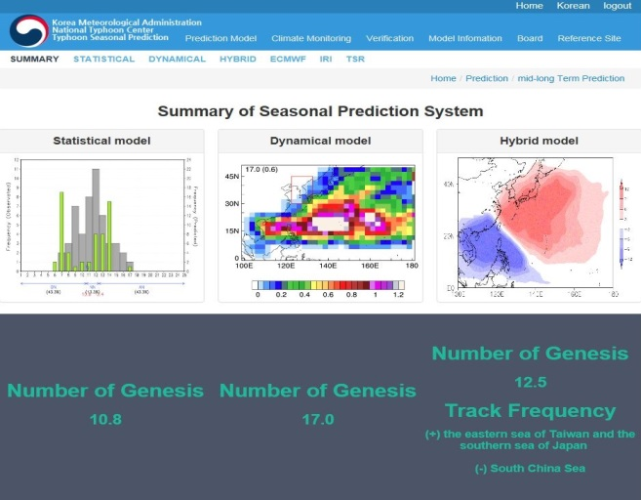

*Fig.Ⅱ-1. Sample pages of the website for the KMA’s seasonal typhoon activity outlook: Summer (Top left), Model prediction result during Jun.-Aug. (Bottom left), Fall (Top right), Model prediction results during Sep.-Nov. (Bottom right)*

**Identified opportunities/challenges, if any, for further development or collaboration:**

**Priority Areas Addressed:**

**Contact Information:**

Member: Republic of Korea

Name of contact for this item: Nam-Young KANG

Telephone: +82-70-7850-6355

Email: nkang.fsu@gmail.com

1. **Technology Transfer of Typhoon Operation System (TOS) to the Department of Meteorology and Hydrology (DMH) of Lao PDR and the Thai Meteorological Department (TMD) of Thailand (POP4)**

The NTC/KMA carried out the Typhoon Operation System (TOS) technology transfer to the Department of Meteorology and Hydrology (DMH) of Lao PDR and the Thai Meteorological Department (TMD) from 8 to 12 October, 2018. This system allows forecasters to produce typhoon information with multi ensemble function for intensity and track forecast by using NWP data in the TOS DB. TOS optimally covers all the member country’s responsible areas and displays their stations. Recently, a new feature of TD forecast has been added as requested (Fig. II-2).

Two staff members of the NTC and two engineers visited the DMH and TMD during their visit installing the TOS system on the Linux server in each country and checking the system working and training status. The transfer included lectures and practice sessions for the forecasters from the DMH and TMD on typhoon forecast with TOS and the structure of the system. The visit to TMD and DMH was made by TCTF support.

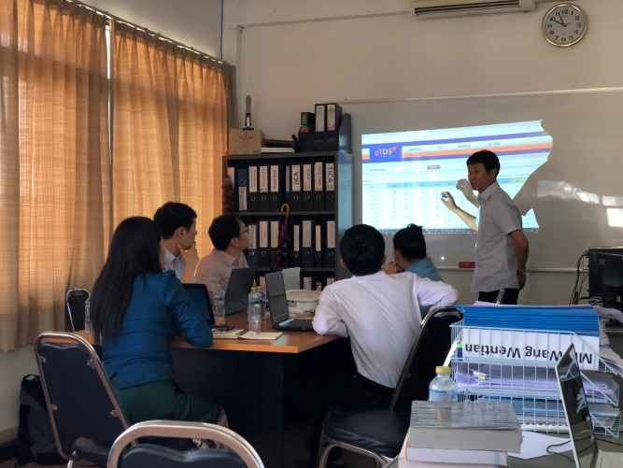 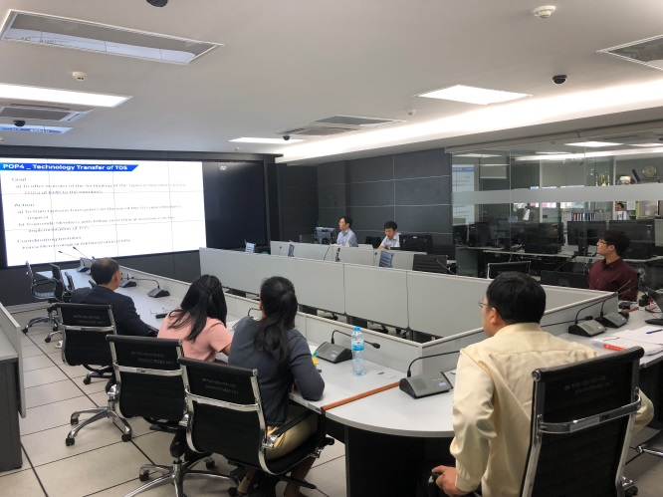

*Fig.Ⅱ-2. TOS introduction and typhoon forecast practice at DMH (left) and TMD (right)*

**Identified opportunities/challenges, if any, for further development or collaboration:**

We will continue TOS technology transfer to Member countries when requested.

**Priority Areas Addressed:**

**Contact Information:**

Member: Republic of Korea

Name of contact for this item: Dongjin KIM

Telephone: +82-70-7850-6365

Email: kdj1105@korea.kr

1. **2018 TRCG Research Fellowship Scheme by KMA**

NTC/KMA hosted the Typhoon Research Fellowship Program of the Training and Research Coordination Group of Typhoon Committee for the ESCAP/WMO Typhoon Committee Members from 23 April to 4 May 2018. This program was joined by five participants from the Philippine Atmospheric Geophysical and Astronomical Services Administration (PAGASA), Vietnam National Center for Hydro-Meteorological Forecasting (NCHMF), the Thailand Meteorological Department (TMD), China Meteorological Administration (CMA), and Malaysian Meteorological Department (MMD).

The participants made and discussed their presentation. And they took part in a session on tropical cyclone analysis and forecast, a practice session using Typhoon Operation System (TOS) at NTC and a session on analysis of satellite and radar data at the National Meteorological Satellite Center (NMSC). Lastly, they visited the KMA headquarters in Seoul and NMSC in Jincheon in the middle part of the Korean Peninsula (Fig. II-3).

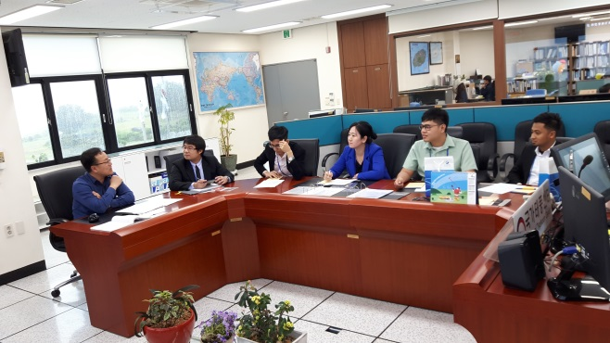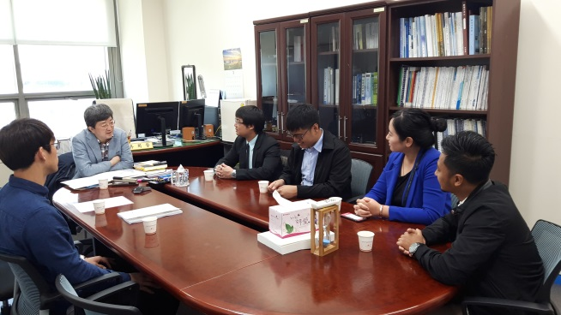

*Fig.Ⅱ-3. Research discussion at NTC (left) and discussion with Director General of Forecast Bureau at KMA (right)*

**Identified opportunities/challenges, if any, for further development or collaboration:**

**Priority Areas Addressed:**

**Contact Information:**

Member: Republic of Korea

Name of contact for this item: Cha Eun Jeong

Telephone: +82-70-7850-6352

Email: kenkyukan@korea.kr

1. **Co-hosting the 11th Korea-China Joint Workshop on Tropical Cyclones**

The 11th Korea-China Joint Workshop was held from 14 to 18 May 2018 in Jeju Island, Republic of Korea. It was joined by approximately sixty experts on tropical cyclones and related fields from KMA, CMA, and relevant agencies and organizations. The workshop was comprised of four sessions including Tropical Cyclone Observation, Model and Assessment I, Model and Assessment II, Climate Perspective, and eighteen presentations including two keynote speeches (Fig. II-4).

The delegates from the NTC/KMA and STI/CMA had a discussion for future collaboration activities. Mutually agreed agendas included exchanging experts regarding the Korea-China Meteorological Collaboration, explanation on numerical model, how to share observation data. And WGM focal point meeting schedule was discussed. Lastly, the next 12th workshop would be held in May 2019 in Shanghai, China.

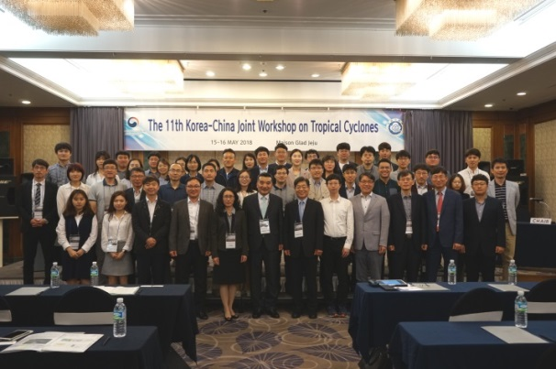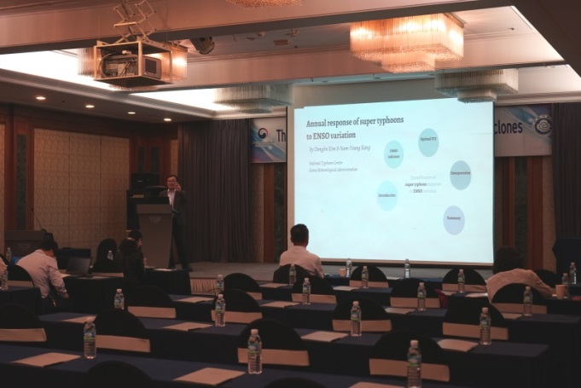

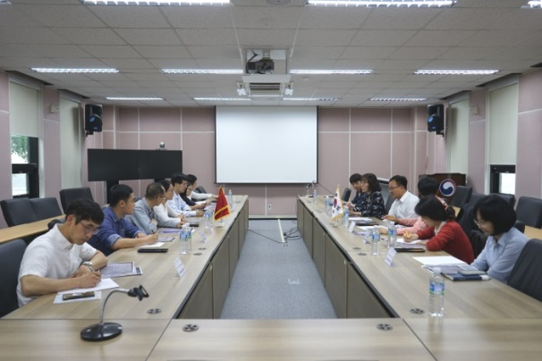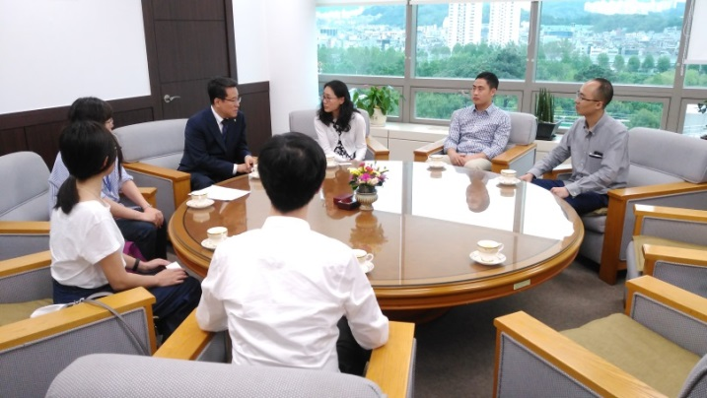

*Fig.Ⅱ-4.Photos of 11th Korea-China Joint Workshop on Tropical Cyclone: Group photo (Top left), discussion between NTC and STI (Bottom left), Keynote lecture by Dr. Kang Namyoung (Top right), a meeting with the Administrator of KMA (Bottom right)*

**Identified opportunities/challenges, if any, for further development or collaboration:**

**Priority Areas Addressed:**

**Contact Information:**

Member: Republic of Korea

Name of contact for this item: Cha Eun Jeong

Telephone: +82-70-7850-6352

Email: kenkyukan@korea.kr

1. **Korean follow-on geostationary meteorological satellite-Geo-KOMPSAT-2A**

KMA has developed the follow-on geostationary meteorological satellite, Geo-KOMPSAT-2A (GK-2A) since 2013. It is scheduled for a launch in December 2018. The Advanced Meteorological Imager (AMI), the payload for the meteorological mission of GK-2A, is comparable to those of the AHI and ABI imager onboard Himawari-8/9 and GOES-16/17, respectively. GK-2A AMI specification on the channel and subsatellite spatial resolution is summarized in Table 1.

True-color images from a combination of the three visible bands (VIS0.4, VIS0.5, and VIS0.6) appear as if seen by the human eye. Near-infrared (NIR) bands 4-6 (NIR0.8, NIR1.3, NIR1.6) provide cloud physical parameter data such as information on the water/ice phase, particle size, and optical thickness. Solar reflectance differences in the visible and NIR bands enable the collection of surface property data such as information on snow/ice cover and vegetation.

The short-wave infrared band 7 (SWIR3.9), which is inherited from the COMS MI, is used to monitor low-level clouds, fog, wildfires, and other phenomena. Bands 8–10 (WV6.2, WV6.9, and WV7.3) in the water vapor absorption band are available, as opposed to the single band for the COMS MI. The water vapor bands are sensitive to middle-to-upper tropospheric humidity, and differences in sensitivity between them provide vertical humidity profile information. Band 11 (IR8.6) is used for thin ice cloud monitoring in conjunction with other atmospheric window bands.

This is also sensitive to volcanic SO2 gas. Band 12 (IR9.6), which is in the ozone absorption band, is used to monitor stratospheric ozone and (indirectly) potential vorticity. There are three bands 13–15 (IR10.4, IR11.2, and IR12.4) in the 10–12 micrometer atmospheric window as opposed to the two (known as “split window bands”) of COMS MI. These are used to monitor ice crystals/water, lower water vapor, volcanic ash, sea surface temperature, and other phenomena.

The atmospheric window band is present on most meteorological satellites and is mainly used at operational weather centers to support real-time weather analysis and forecasting. Band 16 (IR13.3), which is in the CO2 absorption band, is used for cloud top height assignment and estimation of thin cirrus opacity. As shown in Table 1, the highest resolution is 0.5 km at subsatellite point for band 3 in the visible wavelength. Those of other visible bands and band 4 in the near-infrared wavelength are 1km. Other near-infrared bands and all infrared bands have spatial resolution of 2km.

Table II-1. GK-2A AMI specification

|  |  |  |  |
| --- | --- | --- | --- |
| Channel number | Channel name | Center wavelength (micrometer) | Spatial resolution (km) |
| 1 | VIS0.4 | 0.47 | 1 |
| 2 | VIS0.5 | 0.51 | 1 |
| 3 | VIS0.6 | 0.64 | 0.5 |
| 4 | NIR0.8 | 0.856 | 1 |
| 5 | NIR1.3 | 1.38 | 2 |
| 6 | NIR1.6 | 1.61 | 2 |
| 7 | SWIR3.9 | 3.830 | 2 |
| 8 | WV6.2 | 6.241 | 2 |
| 9 | WV6.9 | 6.952 | 2 |
| 10 | WV7.3 | 7.344 | 2 |
| 11 | IR8.6 | 8.592 | 2 |
| 12 | IR9.6 | 9.625 | 2 |
| 13 | IR10.4 | 10.403 | 2 |
| 14 | IR11.2 | 11.212 | 2 |
| 15 | IR12.4 | 12.364 | 2 |
| 16 | IR13.3 | 13.31 | 2 |

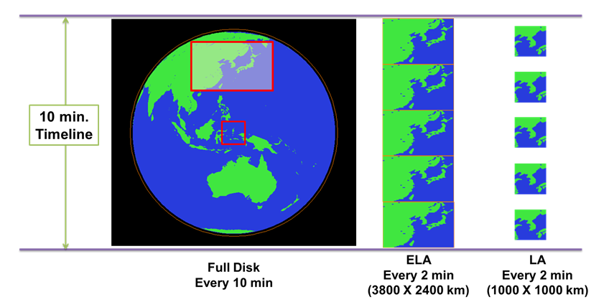

*Fig.Ⅱ-5.AMI observation areas and frequencies on a timeline of 10 minutes*

Fig.Ⅱ-5 shows 10 minute timelines of AMI observation areas and frequencies. The three scans performed by the AMIs are Full Disk (FD), Extended Local Area (ELA), and Local targeted Area (LA). On a specific timeline, the AMI scans the Full Disk once, ELA five times and LA five times.

For the LA observation, the first priority is the disasters monitoring over Korean Peninsular such as Typhoon, wild fire, and so on. But the official request of target area observations by global users over the Asian Pacific region (RA II and RA V) will be available.

The baseline data broadcast policy for GK-2A is to disseminate all 16 channels data of meteorological observations in Ultra HRIT (tentatively named as UHRIT) and to maintain H/LRIT broadcast corresponding to COMS five channels. Table 2 is the current status of international registration request of frequency for GK-2A which was submitted to International Telecommunication Union (ITU) on Jun. 4, 2012. The uplink/downlink frequency domains for GK-2A mission will determined afterward within the requested bandwidth of each frequency band.

Table II-2. International frequency registration request for Geo-KOMPSAT-2A

|  |  |  |
| --- | --- | --- |
| Category | Uplink (MHz) | Downlink (MHz) |
| L-Band | - | 1670-1710 (for L/HRIT) |
| S-Band | 2025-2110 (for UHRIT) | 2200-2290 (for UHRIT) |
| X-Band | 8175-8215 (for UHRIT) | 7450-7550 (for sensor data and UHRIT) |
|  |  | 8025-8400 (for sensor data and UHRIT) |

From the GK-2A AMI observations, 52 kinds of meteorological products will be generated. The meteorological products composed of 23 primary products and 29 secondary products. These are developed by four domestic development teams which are categorized according to characteristics of the products such as scene and surface analysis, cloud and precipitation, aerosol and radiation, and atmospheric condition and aviation as shown in Table 3.

Table II-3. Geo-KOMPSAT-2A meteorological products

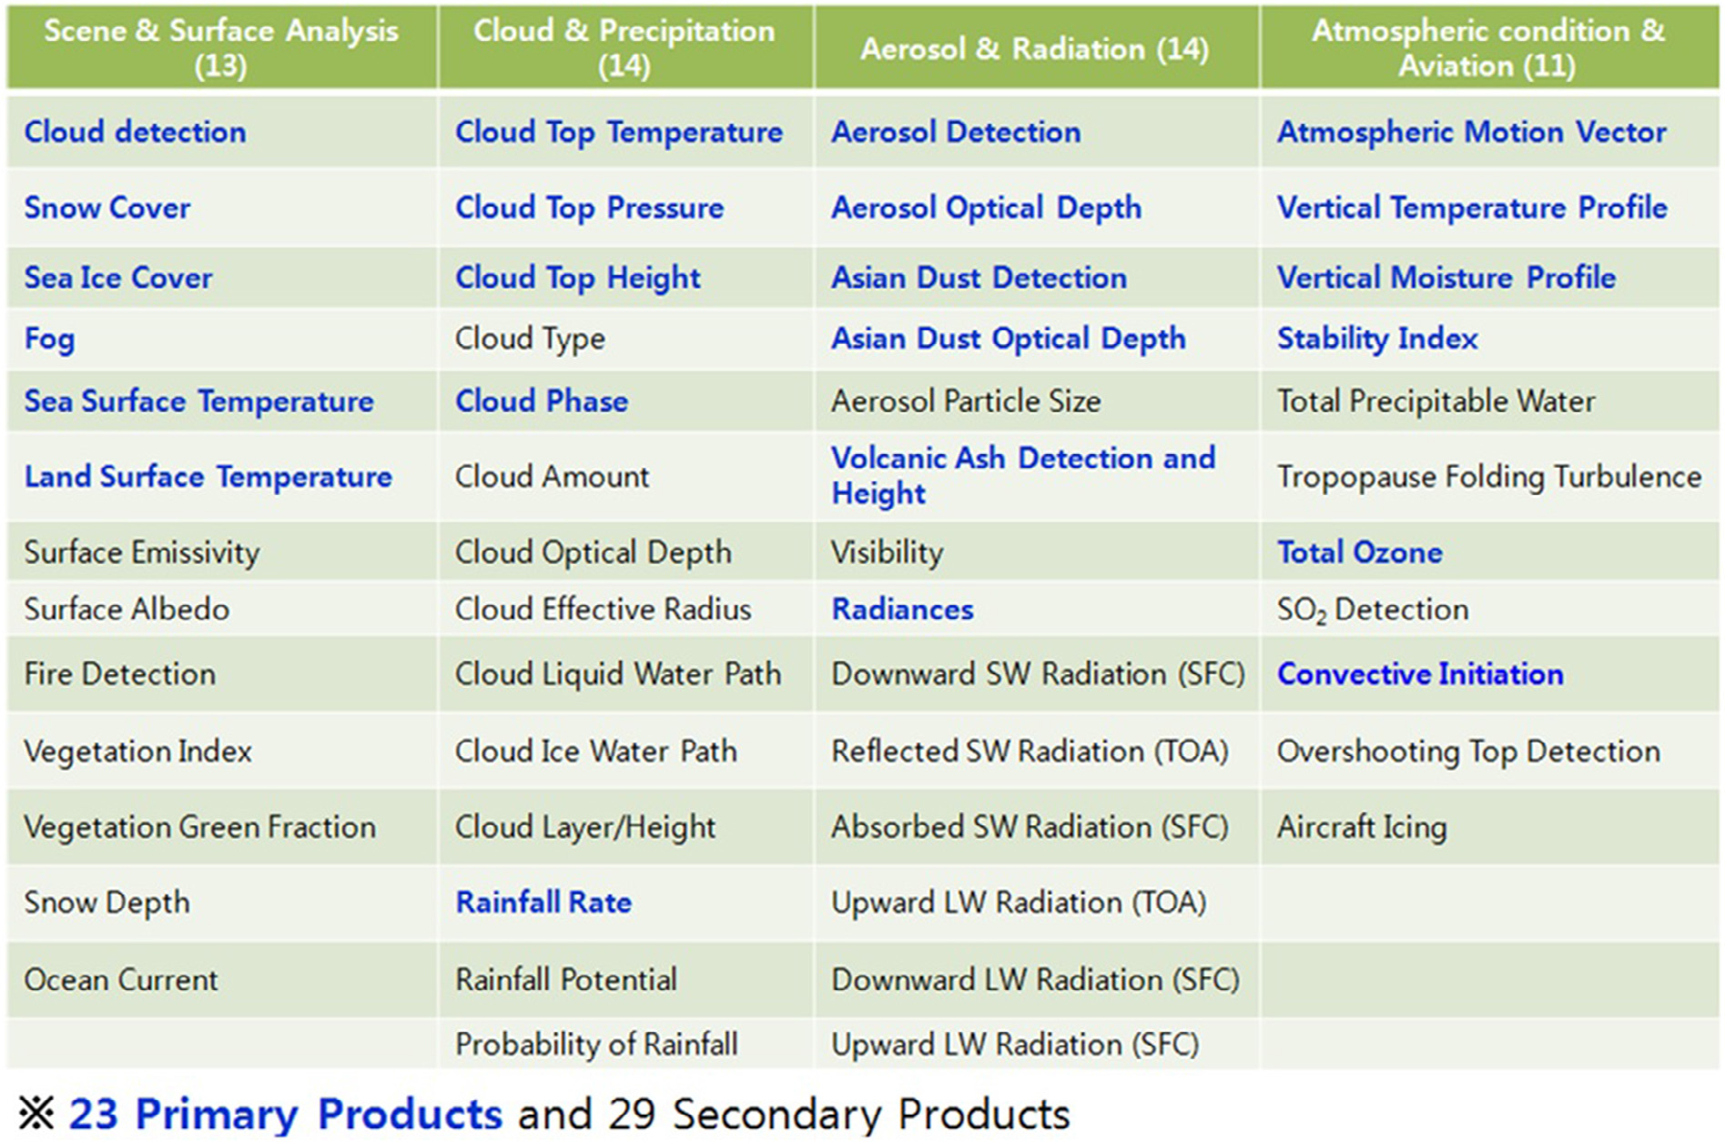

**Identified opportunities/challenges, if any, for further development or collaboration:**

**Priority Areas Addressed:**

**Contact Information:**

Member: Republic of Korea

Name of contact for this item: Chu-Yong CHUNG

Telephone: +82-70-7850-5903

Email: cychung@kma.go.kr

1. **Preliminary Research on Establishment of Hydrological Data Quality Control in TC Members**

Hydrological data quality control is very important for effective flood forecasting. Compared to the importance of hydrological data utilization and management, a system and/or a framework for effective hydrological data quality management are limited and inadequate.

The Republic of Korea has implemented and operated a system for hydrological data quality control for major river watersheds including Han River basin, thereby improving the accuracy and efficiency of flood forecasting.

With this regarding, the project for improvement of hydrological data quality control in TC members has been launched. The objective of this project is to analyze the present state of the beneficiary countries such as Lao PDR, Malaysia, Philippines, and Thailand, and to provide direction and guidelines for the implementation of hydrological data quality control system. In addition, it is to share the hydrological data control techniques of Korea, the system utilization method and its contributions to improvement of flood forecasting. It is expected, eventually, that TC member countries will be able to improve flood forecasting performance by using high quality hydrological data.

Prior to the progress in main components for the project, preliminary studies on the hydrological data quality management for target countries in TC region were conducted.

**Identified opportunities/challenges, if any, for further development or collaboration:**

Conducting project to improve the hydrological data quality helps member countries to enhance the capacity to manage water resources and to respond the flood damage.

**Priority Areas Addressed:**

Improve typhoon-related flood (including river flood, urban flood, mountainous flood; flash flood and storm surge, etc. the same below) monitoring data collection, quality control, transmission and processing

**Contact Information:**

Member: Republic of Korea

Name of contact for this item: Ji Youn SUNG

Telephone: +82-2-590-9985

Email: sungjy@korea.kr

1. **Flood Damage Mitigation and Securing Water through Dam Control in Flooding**

Due to the occurrence of Typhoon SOULIK and subsequent heavy rainfall in South Korea, Chungju Dam, a multi-purpose dam in the Han River basin, exceeded the standard level to prepare for flood. HRFCO decided to discharge the Chungju Dam to lower the water level in consult with dam operation company, K-water.

The heavy rain following the typhoon SOULIK recorded a maximum rainfall of 530 mm across the country. The 20 multi-purpose dams stored about 3 billion ㎥ to minimize damage in the downstream and the amount was gradually released after the end of rainfall.

In addition, the multi-purpose dams, including six dams on the whole nation that were on the drought management stage since early August, secured the dam water approximately 91.1 billion ㎥ of discharge, corresponding to the level of 122 % of the previous year. As a result, it was possible to supply water stably before the flood season of next year.

In the area of Yeoncheon in Gyeonggi-do, about 400 mm of rainfall occurred for just two days from August 28. However, by controlling Gunnam flood control reservoir and Hantangang flood control dam, the water level was lowered by about 1 m to prevent the water level of Paju (Biryong Bridge), which is the flood warning point of Imjin River, from exceeding the flood warning level of 11.5 m.

**Identified opportunities/challenges, if any, for further development or collaboration:**

Korea government plays a leading role for dam operation for flood and drought management, and these cases enable to be a sample how to operate dams.

**Priority Areas Addressed:**

Enhance the capacity in typhoon-related flood risk management (including dam operation), integrated water resources management and flood-water utilization.

**Contact Information:**

Member: Republic of Korea

Name of contact for this item: Ji Youn SUNG

Telephone: +82-2-590-9985

Email: sungjy@korea.kr

1. **Improvement of Works to Expand Flood Forecasting Impacts**

The government of the Republic of Korea has been expanding the temporal and spatial range of flood forecasting (flood warning, flood information, etc.) to reflect the increasing trend in heavy rainfall due to climate change, and is strengthening flood management works so that the situation can be identified and responded quickly.

In this regard, a plan to increase the number of a flood forecast (watch and warning issue) point from current 55 points up to 70 points gradually. Also, in the case of rivers with difficulty in figuring out the lead time for predicting water level, a standard value is set to provide appropriate information based on observation data. In addition, in order to notify the dangerous situation in advance before issuing the flood forecast, it is promoted to expand the point to provide water level information classified into four levels, such as “attention”, “watch”, “warning”, and “severe”.

At the same time, the projects are underway to expand the lead time for forecasting and to develop technology for prediction of flash flood and urban lowland flooding.

In order to respond the event of record-breaking rainfall effectively, effective dissemination system has been considering as a way to prepare for prompt flood management at site. A manual for flood response is planning to be prepared in cooperation with the local governments and other related organizations. In the process, joint simulation training with these organizations is under consideration as the way to collaboration against flood.

**Identified opportunities/challenges, if any, for further development or collaboration:**

The flood management in cooperation with related organizations is the way to respond the flood damage effectively. The manual is available as the reference for member countries.

**Priority Areas Addressed:**

Enhance the capacity in impact-based and community-based operational flood forecasting and early warning, including methodology research, hydrological modeling, and operation system development.

**Contact Information:**

Member: Republic of Korea

Name of contact for this item: Ji Youn SUNG

Telephone: +82-2-590-9985

Email: sungjy@korea.kr

1. **Enhancement of Flood Forecasting Reliability with Radar Rainfall Data**

In the case of recent torrential rainfall, local variability is so severe that there are many difficulties in implementing flood forecasting and other flood-prevention tasks. Localized heavy rainfall is usually short in duration time and strong in intensity, leading to high peak floods and rapid outflows. In order to manage these flash floods, it is necessary to have very densely observable rainfall data. However, it is not practical to install a lot of rainfall observation stations in the watershed and to observe the rainfall observations in terms of the installation and maintenance cost of the stations. To solve these problems, the rainfall radar system is operated as a complementary measure.  
 The use of radar rainfall data can be usually classified into two types. The first is the radar image data monitoring and the second is the grid type rainfall distribution data for the hydrological field application such as the flood discharge.

The project that provides a methodology and a technique to enhance flood forecasting reliability with radar rainfall data has just launched. The project aims to analyze the status of operation and flood forecasting with rain radar data.

In this year, four beneficiary countries have been selected to survey for the status of the radar data application and operation rules for flood forecast.

**Identified opportunities/challenges, if any, for further development or collaboration:**

Through the AOP project led by Korea, member countries can enhance their radar data application for flood forecast.

**Priority Areas Addressed:**

Enhance the capacity in advanced technology (including satellite data, GIS, RS, QPE/PQF, ensemble, parallel computing) utilization in typhoon-related flood forecasting and early warning, and hydrological modeling.

**Contact Information:**

Member: Republic of Korea

Name of contact for this item: Ji Youn SUNG

Telephone: +82-2-590-9985

Email: sungjy@korea.kr

1. **The Flood Risk Map and Information Service of the Waterfront Inundation**

The flood risk map is important and basic information for local government to establish their action plan against floods. HRFCO has been conducting the flood risk mapping for several years, and the mapping of flood risk for national rivers has already been completed. As the next step, flood risk mapping of provincial rivers is ongoing, and the completed maps is planned to release to the local government on the Han River basin in this year. The works on Nakdong River basin started in this year and it will expand to other basins to be finalized until the year 2021.

The waterfront inundation information service, in order to support the safe activities and the facilities management, began in earnest on Han River and Yeongsan River basins. And the system construction started on Geum River and Nakdong River basins from this year. In this year, the forecasted inundation area images on the waterfront were offered by smartphone application.

**Identified opportunities/challenges, if any, for further development or collaboration:**

The member countries have much interest in the flood risk mapping and the information service, so the tasks and technologies can be shared and connected with other countries project to improve the achievement.

**Priority Areas Addressed:**

Enhance the capacity in flood risk (hazard, inundation) information, mapping and its application.

**Contact Information:**

Member: Republic of Korea

Name of contact for this item: Ji Youn SUNG

Telephone: +82-2-590-9985

Email: sungjy@korea.kr

1. **Setting up Early Warning and Alert System in Vietnam and Lao PDR 2018**

At the 9th Annual Meeting of WGDRR in 2014, Lao PDR and Vietnam requested NDMI to implement ODA project in their countries. After investigating feasibility study of the two countries, NDMI implemented a new project to build up capabilities of flash flood in 2016.

The ODA process, which installed a Flash Flood Alert System (FFAS) and Automatic Rainfall Warning System (ARWS), by NDMI has three steps:

1. Feasibility study
2. Installation and Inspection

\* Installation of ARWS: Warning Post (WP), Rainfall Level Gauge (RG), Water Level Gauge (WG)

1. Education program to use FFAS and ARWS

In 2016 and 2017, NDMI had implemented ODA project including the feasibility study, the installation and inspection, and the education program in both countries.

Table II-4. The number of ARWS and FFAS installed in Vietnam and Lao PDR

|  |  |  |  |  |  |  |
| --- | --- | --- | --- | --- | --- | --- |
|  | Lao Cai, Vietnam | |  |  | Oudomxay, Lao PDR | |
|  | 2016 | 2017 |  |  | 2016 | 2017 |
| WP | 2 | 2 |  | WP | 2 | 2 |
| RG | 2 | 2 |  | RG | 2 | 2 |
| WG | 2 | 2 |  | WG | 2 | 2 |
| FFAS | 1 | 1 |  | FFAS | 1 | 1 |

<Activities in Vietnam 2018>

Through discussion with Vietnam Academy for Water Resources (VAWR) and implementing the feasibility study, NDMI decided to install ARWS in Yenbai due to damage from flooding last year. In discussion with VAWR and Yenbai province, NDMI chose 2 places for WP, 2places for RG, and 2 places for WG in Nghia Lo, Yenbai province. NDMI would inspect and check ARWS in 2018 October and make a plan for the education program in December 2018.

<Activities in Lao PDR 2018>

With discussion with Department of Metrology and Hydrology (DMH) and implementing the feasibility study, NDMI made a decision to install ARWS in Oudomxay, 4 places for WP, 4 places for RG, and 4 places for WG. NDMI would check ARWS in 2018 October and plan to implement the educational program in December 2018.

**Identified opportunities/challenges, if any, for further development or collaboration:**

NDMI will expand the project period from 2016 – 2018 to 2016 – 2019 in both countries to build up capacities of a flash flood system.

**Priority Areas Addressed:**

Enhance the capacity for flash flood in Vietnam and Lao PDR.

Make a strong partnership and collaboration between Republic of Korea, Vietnam, and Lao PDR.

**Contact Information:**

Member: Republic of Korea

Name of contact for this item: Lee, Chi Hun

Telephone: +82-52-928-8190

Email: chihun@korea.kr

1. **Participation in Training Workshop for TC Community Weather Station Project (iCoWIN) 2018**

NDMI had received an iCoWIN invitation from Hong Kong Observatory (HKO) for this year. One of NDMI experts in the field of disaster management was asked to participate in the training workshop. The Training Workshop for TC Community Weather Station Project is held in HKO from 5 to 7 November 2018 and main theme is ‘Setting up of community weather stations for raising public awareness on climate change and extreme weather’.

The training workshop aims to not only strengthen TC members’ capacities in setting up community weather stations for raising public awareness on climate change but also promote the use of new communication strategies and technology to facilitate sharing of weather information among community. The expert in NDMI will make a presentation about weather station and activities in Korea and NDMI.

The workshop will include:

1) Overview of the Hong Kong Observatory’s Community Weather Information (Co-WIN) and Typhoon Community’s iCoWIN Programme

2) Presentation by Participants regarding weather stations and observations strategy in their countries (NDMI: Dr. Gwak, Yong Seok)

3) Introduction to Community Weather Station (CWS)

4) Practical: Setting up a community weather station

5) Visit to Tai Mo Shan Weather Radar station and Ho Koon Nature Education cum Astronomical Centre (a member of Co-WIN in Hong Kong)

**Identified opportunities/challenges, if any, for further development or collaboration:**

NDMI would not only share the knowledge of weather and climate change but also enhance TC Members’ capacities in setting up of community weather stations for raising public awareness on climate change

**Priority Areas Addressed:**

Enhance the capacity in setting up community weather stations for raising public awareness on weather.

Share weather information among TC members and promote the use of new communication technology.

**Contact Information:**

Member: Republic of Korea

Name of contact for this item: Lee, Chi Hun

Telephone: +82-52-928-8190

Email: [chihun@korea.kr](mailto:chihun@korea.kr)

1. **The 13th Annual Meeting of Typhoon Committee Working Group on Disaster Risk Reduction**

The 13th Annual Meeting of Typhoon Committee Working Group on Disaster Risk Reduction (WGDRR) was held in Ulsan, Republic of Korea from 29th May to 1st June 2018. Around 40 participants from international organizations and universities such as UNESCAP, university of Hawaii, Tohoku University, and etc. discussed international cooperation for DRR.

The topic for the annual meeting was ‘Public Understanding of Science in Disaster Risk Reduction (From Desk to Field)’. TC members in the meeting shared public awareness of science for DRR and strategies for 2018 Annual Operational Plans (AOPs).

Table II-5. Annual Operation Plans of WGDRR in 2018

|  |  |  |  |
| --- | --- | --- | --- |
| **No.** | **Items** | **No.** | **Items** |
| **1** | Expert Mission | **7** | Benefit Evaluation of Typhoon DRR |
| **2** | Setting up Early Warning and Alert System | **8** | Supporting SSOPII Project |
| **3** | iCowin Project | **9** | Sharing Information related to DRR |
| **4** | WGDRR Annual Meeting | **10** | TC Report about Big Data and Social Media use for DRR |
| **5** | Promote TC-PTC Cooperation |
| **6** | Participation in the PRiMO Conference | **11** | Making Education Videos related to DRR |

|  |  |
| --- | --- |
| C:\Users\user\Desktop\0.다운로드\7. 태풍위원회\방재분과 연례회의\2018\USB_13th WGDRR Annual Meeting\Photo - 13th WGDRR Annual Meeting\2. May 30\IMG_5114.JPG | C:\Users\user\Desktop\0.다운로드\7. 태풍위원회\방재분과 연례회의\2018\USB_13th WGDRR Annual Meeting\Photo - 13th WGDRR Annual Meeting\2. May 30\IMG_5037.JPG |
| **C:\Users\user\Desktop\0.다운로드\7. 태풍위원회\방재분과 연례회의\2018\USB_13th WGDRR Annual Meeting\Photo - 13th WGDRR Annual Meeting\3. May 31\2. NDMI Field Trip\IMG_5276.JPG** | **C:\Users\user\Desktop\0.다운로드\7. 태풍위원회\방재분과 연례회의\2018\USB_13th WGDRR Annual Meeting\Photo - 13th WGDRR Annual Meeting\4. June 1\2. Traditional Pottery in Onggi\DSC_5603.JPG** |

*Fig.Ⅱ-6.Photos of 13th Annual Meeting of Typhoon Committee Working Group on Disaster Risk Reduction (Top), field trip in experimental center, NDMI (Bottom left) and in Onggi village (Bottom right)*

At the meeting, not only TC members’ cases for the Public Understanding of Science (PUS) were discussed, but also the implementation of AOPs was involved in the main topic. Compared to last year, there were additional activities such as the PRiMO conference.

**Identified opportunities/challenges, if any, for further development or collaboration:**

NDMI intend to promote sharing of PUS for DRR among TC members. Also, NDMI want to establish a strong tie between TC members by discussion of international activities such as expert mission, PRiMO conference, iCowin project, and etc.

**Priority Areas Addressed:**

Develop and enhance partnership among TC members and promote sharing of PUS for DRR.

Promote the using of the technical strategies and communication skills for DRR.

Strengthen target F of Sendai Framework which is ‘substantially enhance international cooperation to developing countries through adequate and sustainable support to complement their national actions for implementation of this framework by 2030’

**Contact Information:**

Member: Republic of Korea

Name of contact for this item: Lee, Chi Hun

Telephone: +82-52-928-8190

Email: chihun@korea.kr

1. **Participation in the PRiMO Conference**

The Pacific Risk Management Ohana (PRiMO) Conference was held in Hawaii from August 6th to 9th. The main topic was ‘Technology and Disaster Risk Reduction: The Good, the Bad, and the Ugly’.

The conference made communities more resilient by bringing people and organizations together, and channeling their efforts toward common goals. NDMI had one concurrent session which was in August 8 from 1:30pm to 3:00pm. The topic of the session by NDMI was ‘Increasing Public Understand of Science to Enhance Disaster Risk Reduction’.

|  |  |
| --- | --- |
| EMB00000eb036c4 | EMB00000eb036c6 |
| <Dr. Kim, Yuntae, NDMI> | <Dr. Lee, Miran, NDMI> |
| EMB00000eb036c8 | EMB000009fc0d6d |
| <Dr. Hong, Sungjin, NDMI> | <Dr. Kim, Haksoo, NDMI> |
| EMB000009fc0d6f | EMB000009fc0d78 |
| <Dr. Kim, Dowoo, NDMI> | <Dr. Lee, Chihun, NDMI> |

*Fig.Ⅱ-7.6 Participants from NDMI at 2018 PRiMO Conference*

6 participants from NDMI made a presentation:

1. International Cooperation on DRR in Asia-Pacific Area by Dr. Lee, Chihun
2. Urban Flood Monitoring System by Dr. Kim, Yuntae
3. Tsunami Hazard Mapping through Characteristics Analysis of Inundation by Dr. Hong, Sungjin
4. Experimental Research and Evacuation Training Programs in Flooded Areas in Experimental Research Center of NDMI by Dr. Kim, Haksoo
5. Disaster Profiling for Case-based Cause Analysis by Dr. Lee, Miran
6. Risk Scanning from Text Big Data by Dr. Kim, Dowoo

|  |  |
| --- | --- |
| EMB000009fc0df3 | EMB000009fc0d58 |
| <Discussion for DRR> | <Dr. Qunna Yang, CMA> |
| EMB000009fc0d59 | EMB000009fc0d56 |
| <Dr. Nyuyen Tung Phong, VAWR> | <Dr. Masaru Arakida, ADRC> |

*Fig.Ⅱ-8. 3 Participants from DRR member countries*

**Identified opportunities/challenges, if any, for further development or collaboration:**

NDMI could make a regional partnership with the Asia-Pacific area for DRR. New technologies such as AI, UAV, and VR for DRR were discussed. Especially, technologies by NDMI including urban flood monitoring system, risk scanning from text big data, and disaster profiling were shared with other countries.

**Priority Areas Addressed:**

Share new technologies for DRR with international organizations and enhance the regional partnership in Asia-Pacific area.

Gather ideas for issues related to DRR such as effective resource distribution in damaged areas, communication between government and the public, and identification of critical resource needs for DRR.

**Contact Information:**

Member: Republic of Korea

Name of contact for this item: Lee, Chi Hun

Telephone: +82-52-928-8190

Email: chihun@korea.kr

1. **Sharing Information related to Disaster Risk Reduction**

As one of AOPs of WGDRR, NDMI has been trying to share information related to DRR at ESCAP/WMO Typhoon Committee site. At the TC site, there is TC Forum session which consists of two parts:

1. Shanghai Typhoon Institute Typhoon BBS: A discussion platform for typhoons, moderated by Shanghai Typhoon Institute (STI) and Typhoon Committee Secretariat (TCS).
2. Typhoon Committee Forum: A discussion platform among the working groups of Typhoon Committee.

\*Three working groups: Working group on Meteorology (WGM), Working Group on Hydrology(WGH), Working Group on Disaster Risk Reduction(WGDRR)

NDMI has been responsible for the WGDRR session to share information related to DRR.

Topics in the session are:

1. Enforcement decree of the framework act on the management of disaster and safety by Korea
2. Framework act on the management of disaster and safety in the republic of Korea by Korea
3. USA Stafford Act by USA
4. Thailand’s Act 2007 and National Plan 2015 by Thailand

`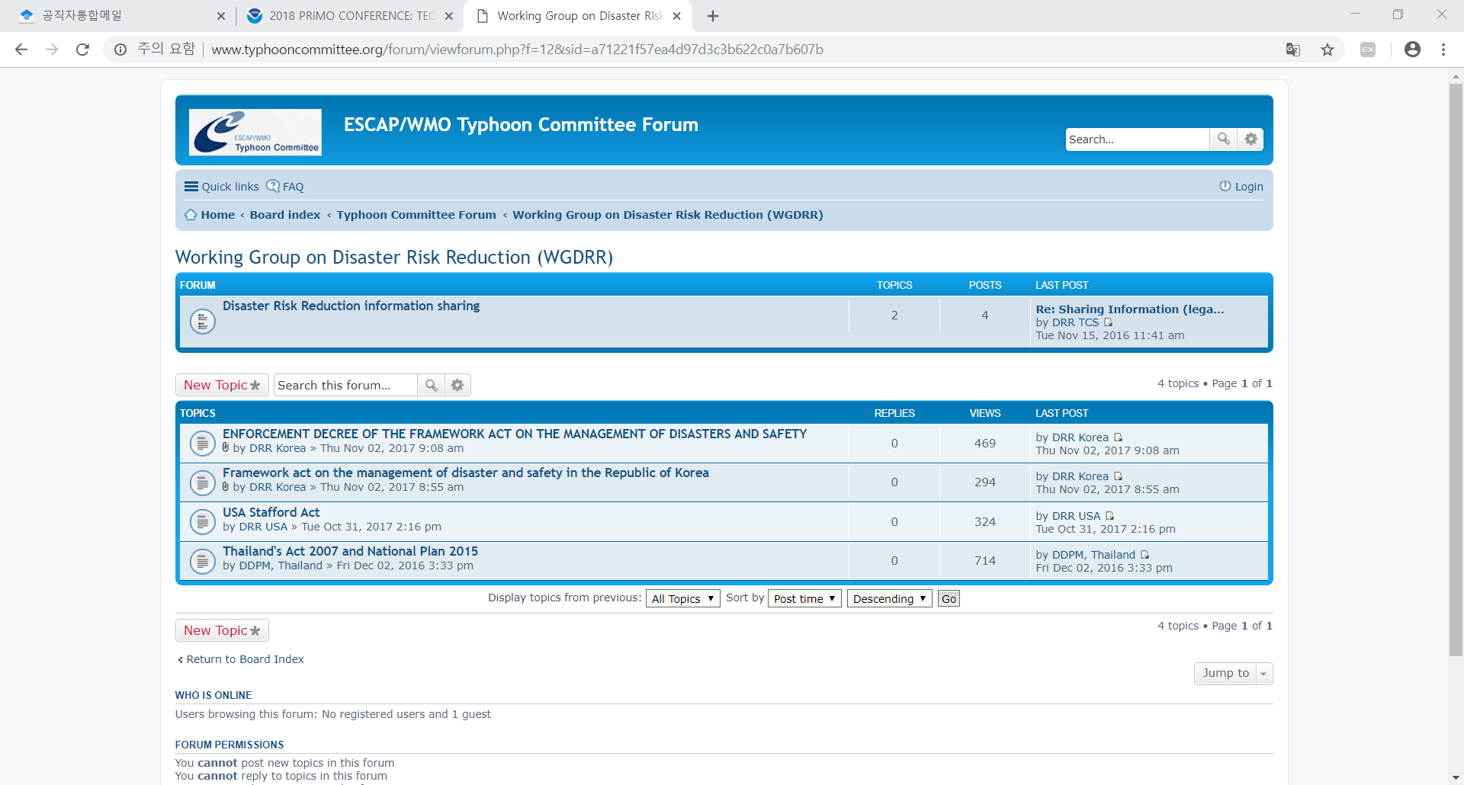

*Fig.Ⅱ-9.WGDRR Forum website*

*http://www.typhooncommittee.org/forum/viewforum.php?f=12&sid=a15b03991a600a6f3c647c15c1b289d1*

**Identified opportunities/challenges, if any, for further development or collaboration:**

Sharing information related to DRR through the TC forum website is good framework to collaborate among TC members. It could be a good opportunity to share information related to disasters to the public. Therefore, NDMI will keep promoting the use of the website so that all knowledge and experience from TC members could be shared to people.

**Priority Areas Addressed:**

Share knowledge related to DRR among TC members, and strengthen the capacity to make a strong tie and partnership with not only TC members but also international organizations.

**Contact Information:**

Member: Republic of Korea

Name of contact for this item: Lee, Chi Hun

Telephone: +82-52-928-8190

Email: chihun@korea.kr

1. **Making Education Video related to Disaster Risk Reduction**

The 13th Annual Meeting of TC WGDRR was held in Ulsan, Republic of Korea in 2018 and public understanding about disaster risk reduction was discussed at the meeting. Moreover, participants such as UNESCAP and experts in disaster management field discussed Annual Operational Plans (AOPs) to strengthen international cooperation for implementation of Sendai Framework. Among all 11 AOPs of 2018 WGDRR, there is one goal to share information of disaster management. The goal is ‘Making education video related to disaster risk reduction’. The education video is about disaster safety measure for urban floods. The video explains how urban floods are risk to people and shows risk experiment by NDMI.

|  |  |
| --- | --- |
|  |  |
|  |  |

*Fig.Ⅱ-10. Making Education Video about Urban Floods*

The video will be released to all TC members to share information and NDMI could provide video without sounds so that members can make their education video with their own language. TC will discuss how to use the videos to improve international cooperation in the near future.

**Identified opportunities/challenges, if any, for further development or collaboration:**

Through sharing the education video among TC members, NDMI could implement the target 7 of Sendai Framework which is substantially enhance international cooperation to developing countries through adequate and sustainable support to complement their national actions for implementation of this framework by 2030. Implementing the target could build up the capabilities of disaster management. Also, the education video will help implementing Sustainable Development Goals (SDGs) by strengthening partnership and sharing information.

**Priority Areas Addressed:**

Develop and enhance the capacity to share information of DRR with other countries and strengthen partnership among TC members.

**Contact Information:**

Member: Republic of Korea

Name of contact for this item: Lee, Chi Hun

Telephone: +82-52-928-8190

Email: chihun@korea.kr

1. **Expert Mission**

At the 13th Annual Meeting of TC WGDRR, representatives from TC members and experts in disaster management discussed Expert Mission 2018. Expert Mission is knowledge exchange program between countries and started from 2008. In order to exchange knowledge and experience on flood protection and river management, NDMI had had a discussion with Macau at the annual meeting.

The mission was supposed to be held in Macao in 2018 to share knowledge and information across two main technical areas:

1. Disaster risk reduction, including prevention, early warning systems, disaster management system, and emergency operations
2. International Cooperation between Macao and Korea for Disaster Risk Reduction

However, 2018 Expert Mission was canceled because of schedule problem and Macao government’s other business.

**Identified opportunities/challenges, if any, for further development or collaboration:**

NDMI will talk about the Expert Mission 2019 with TC members to share knowledge and information of disaster risk reduction, disaster management system, and emergency operations.

**Priority Areas Addressed:**

Strengthen partnership among TC members and promoting sharing information and experience about technical areas such as prevention, early warning systems, and emergency operations.

**Contact Information:**

Member: Republic of Korea

Name of contact for this item: Lee, Chi Hun

Telephone: +82-52-928-8190

Email: chihun@korea.kr